**Assessment tools feature Documentation**

**Purpose**

To provide a way for users to quantify progress/work done and provide feedback

**Background**

The main way to quantify progress is with assessment activities like quizzes and assignments. The main way of getting feedback is with comments on those same activities and forums and surveys.

**Usage**

-You can take the example of a Senior Educator setting a multiple choice question.  
By choosing that answer, one can get the feedback that the Educator desires the Learner to pick from as shown below:

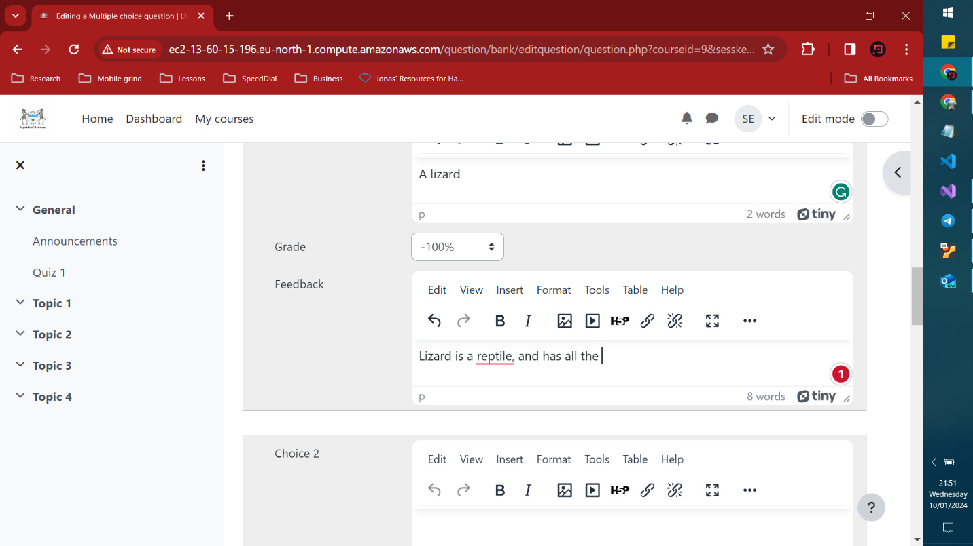

-After a student submits an assignment, (say a 200 word document) an Educator can come in and give feedback comments on what it is that the student should realize and pick up on

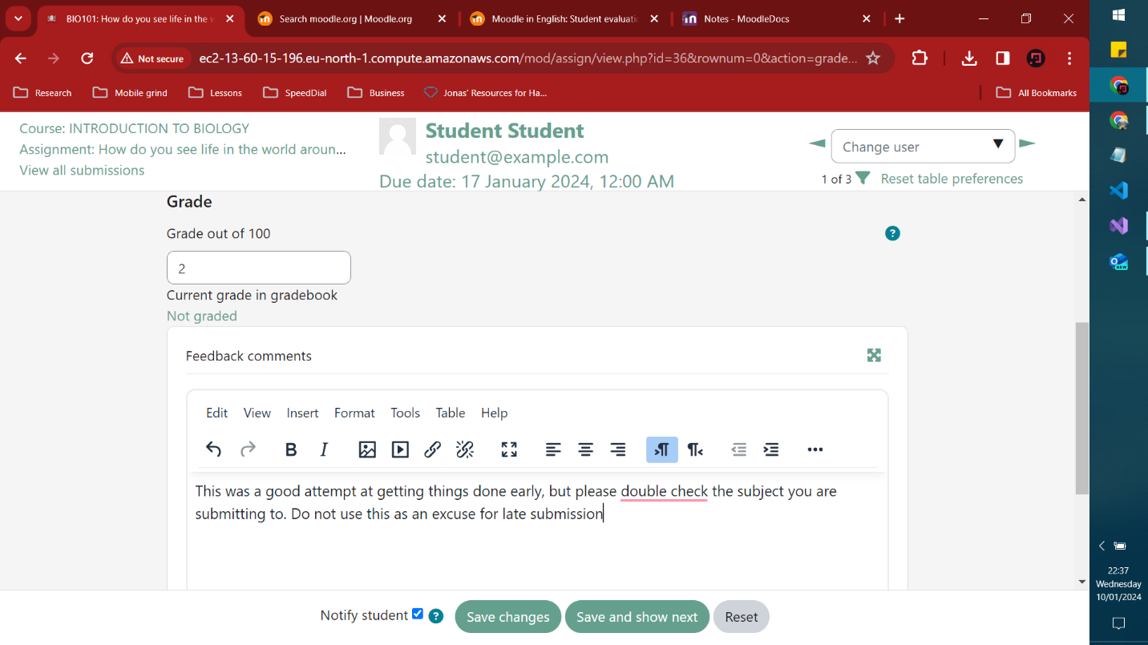

-An Educator can also leave notes for other Educators to read through so that they can appreciate lessons learnt about the individual. They can access this resource by going to the students profile and then click under miscellaneous> Notes

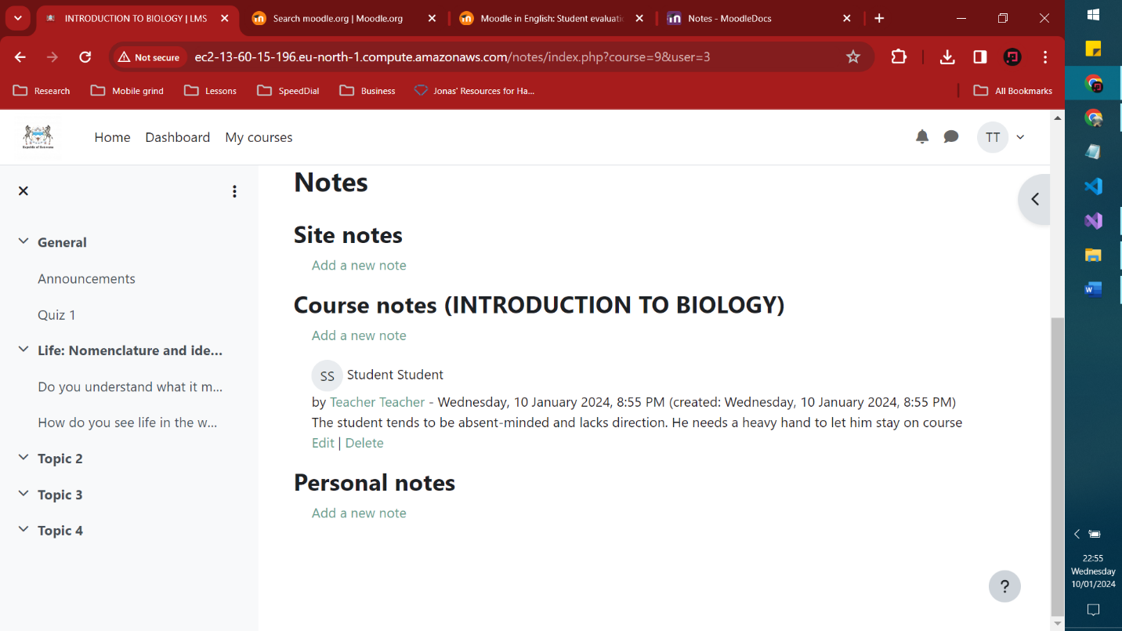

Finally an Educator can add a Feedback activity for the students to speak on what ever the Educator sets as. Below we have an example of an Educator assessment from a students perspective:

